Hi Natalyia

Here are updates remaining, please note some of the functions are now not operating (I will describe which ones in a separate section below). IN general home page needs to be more tight:

LOGO

* Needs to be slightly bigger
* Too much space above and below logo, let’s try and remove FOOD FOR ALL OCCASIONS and only leave phone number – then move pictures to the logo (now bigger) and home page header links

ADD CDC CATERING LOGO after PHONE NUMBER (logo below)

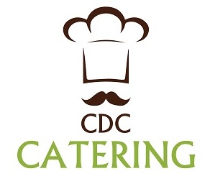

HOME PAGE HEADER (picture below)

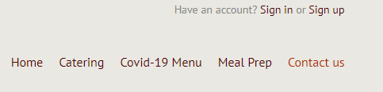

* Sign in or Sign up is too high, lower it down please and position closer to other header titles
* Change subtitles and now in two lines (make sure it’s concise and it doesn’t appear like two separate things, but top and bottom line are close wnough – Please use some common sense)

Below are samples of right and wrong:

Wrong

Home Traditional Touch-Less Menu Employees Contact Us

Catering Covid-19 ServeSafe Meal Prep

Example of right spacing:

**Home Traditional Touch-Less Menu Employees Contact Us**

**Catering Menu Covid-19 ServeSafe Meal Prep**

HOME PAGE PICTURES

NOTE: All 3 Pictures on home page are links – click on each picture performs the same as click on that category title

* Here is new picture for TRADITIONAL CATERING (and also picture for Meal Prep is following it)

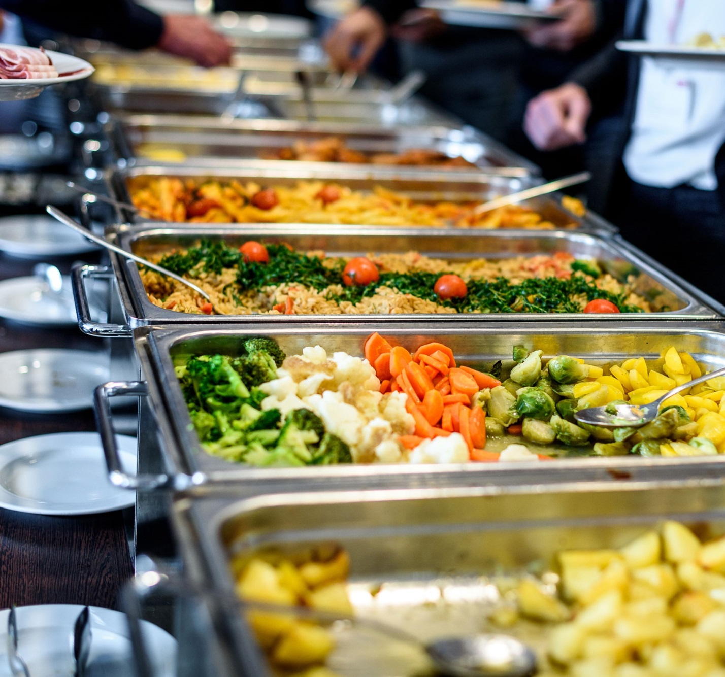

BELOW IS PICTURE FOR MEAL PREP

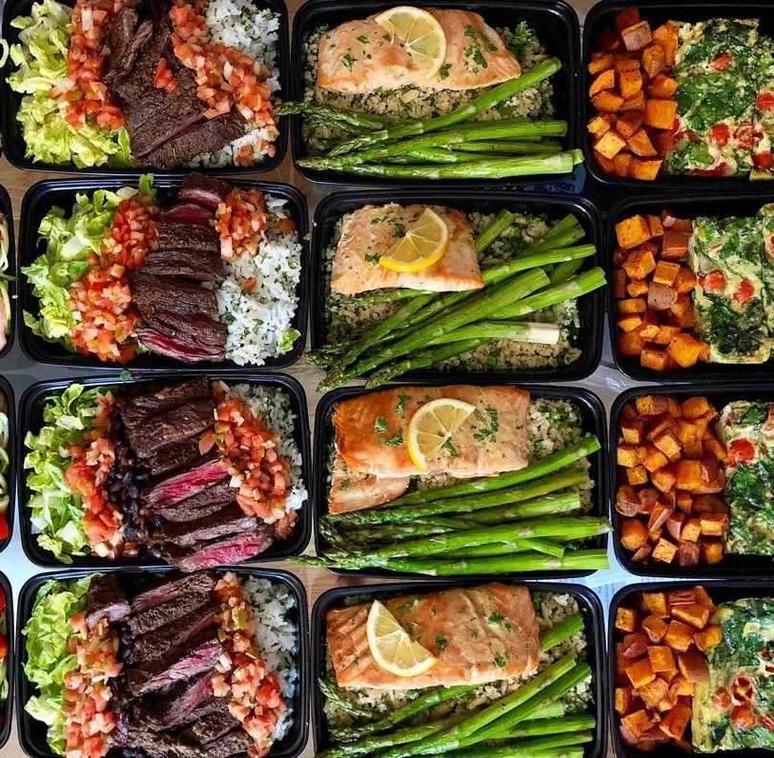

* Icons inside bow – STOP COVID and FREE DELIVERY - Both icons should be slightly (just slightly) bigger in size
* Both icons are positioned bit to low… please try and pull them slightly up

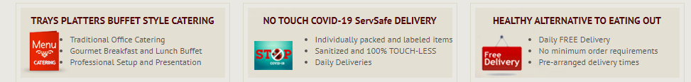

BELOW PICTURE – Blue titles are aligned to the left and color-Burgundy titles (inside boxes) are centered

* They all should be either centered or aligned left (I will trust your designer’ discretion and do it either way you think fits better)

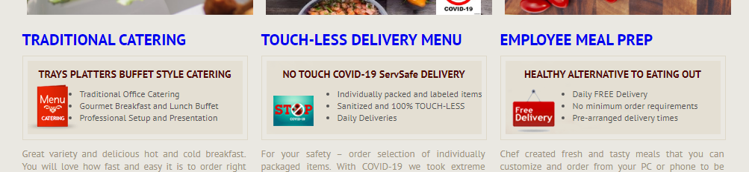

* TOUCH-LESS ~~DELIVERY MENU~~ please change to **TOUCH-LESS CATERING** 
* Place “hand icon” next to it please make sure it’s centered and fits nice
* Subtitle in that box (NO TOUCH COVID-19 ServSafe DELIVERY) please change to:

**NO TOUCH DELIVERY Covid-19 ServSafe** (also make it BIGGER and change color to orange)

* NOTE: All Subtitles in boxes (TRADITIONAL CATERING and EMPLOYEE MEAL PREP please make them bigger and change color from burgundy to dark orange – similar or stronger than logo orange)

**TRAYS PLATTERS BUFFET STYLE** and **HEALTHY ALTERNATIVE TO EATING OUT**

FONTS ON SUBMENU CATEGORIES

* Fonts are still not visible and should be the same as Category Title (please see below)

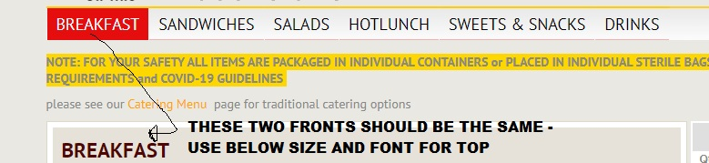

* I would like to change the Category Title color (to Orange)

CONTAC US PAGE

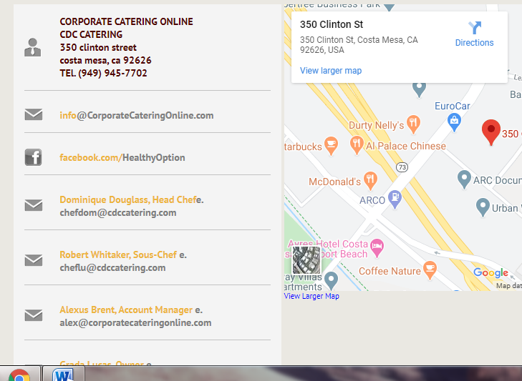

* Change[~~info@corproatecateringonline.com~~](mailto:info@corproatecateringonline.com) into orders@corporatecateringonline.com
* After Facebook field > add Instagram field (Instagram.com/cdccatering)
* Replace email for Robert Whitaker into chefrob@cdccatering.com
* Remove ‘e.’ after each Person’s name
* Un-bold email addresses (but keep names bolded)
* Grada ~~Lucas~~ change to Grada Lucich

MAP POSITION – click x 2 times on minus and hold zoomed out view (one that doesn’t show all local businesses (but rather only pins our address)

